Research and development on Robotic Drives (Week 1)

Team Mentor - Siddharth Kulkarni
Team Members:
- Sushant Koul
- Krish Gandhi
- Aranis Sinha

Objectives:
The primary objective for this week was to study and perform R&D on the Clearpath Jackal robot platform and develop a similar compact differential skid-steer robotic chassis capable of handling an approximate payload of 25 kg.
The robot is being designed as a modular plug-and-play platform capable of supporting components such as LiDAR, robotic arms, cameras, and other testing equipment for different robotics applications.
This week mainly focused on:
- Ideation and drivetrain planning
- CAD design of the chassis
- Structural analysis and validation
- Initial manufacturing and fabrication of the chassis
The chassis was designed while considering compactness, structural strength, modularity, and ease of future modifications.

Ideation:
The project began with an introductory discussion with our mentor, Siddharth, where we were instructed to study the design and functionality of the Clearpath Jackal robot, as our goal was to develop a similar compact and robust robotic platform. One of the major constraints was maintaining dimensions similar to the Jackal UGV while designing a robot capable of handling an approximate payload of 20–25 kg.
Initially, Sushant and Aranis started the research and ideation process while Krish joined later due to college examinations. During this phase, Sushant studied the Jackal robot and prepared a checklist of important design considerations, drivetrain configurations, and structural requirements that the team should follow. The mentor initially suggested constructing the chassis entirely using 20x20 aluminium extrusion profiles. Multiple chassis layouts and drivetrain configurations were discussed before finalizing a differential skid-steer drive system using chain transmission, where two motors control four wheels. Due to space constraints within the maximum chassis dimensions of 500 mm × 500 mm, the motors were placed diagonally while dead shaft assemblies were positioned on the opposite side for power transmission.
Several ideas were proposed during the discussions. Krish suggested using a solid metal base plate for the chassis, but this was rejected due to concerns regarding bending under impact loads and reduced structural efficiency. He also proposed removable motor mounting plates, allowing the entire motor assembly to be detached or repositioned easily for future modifications and maintenance. This modular approach was later approved by the mentor.
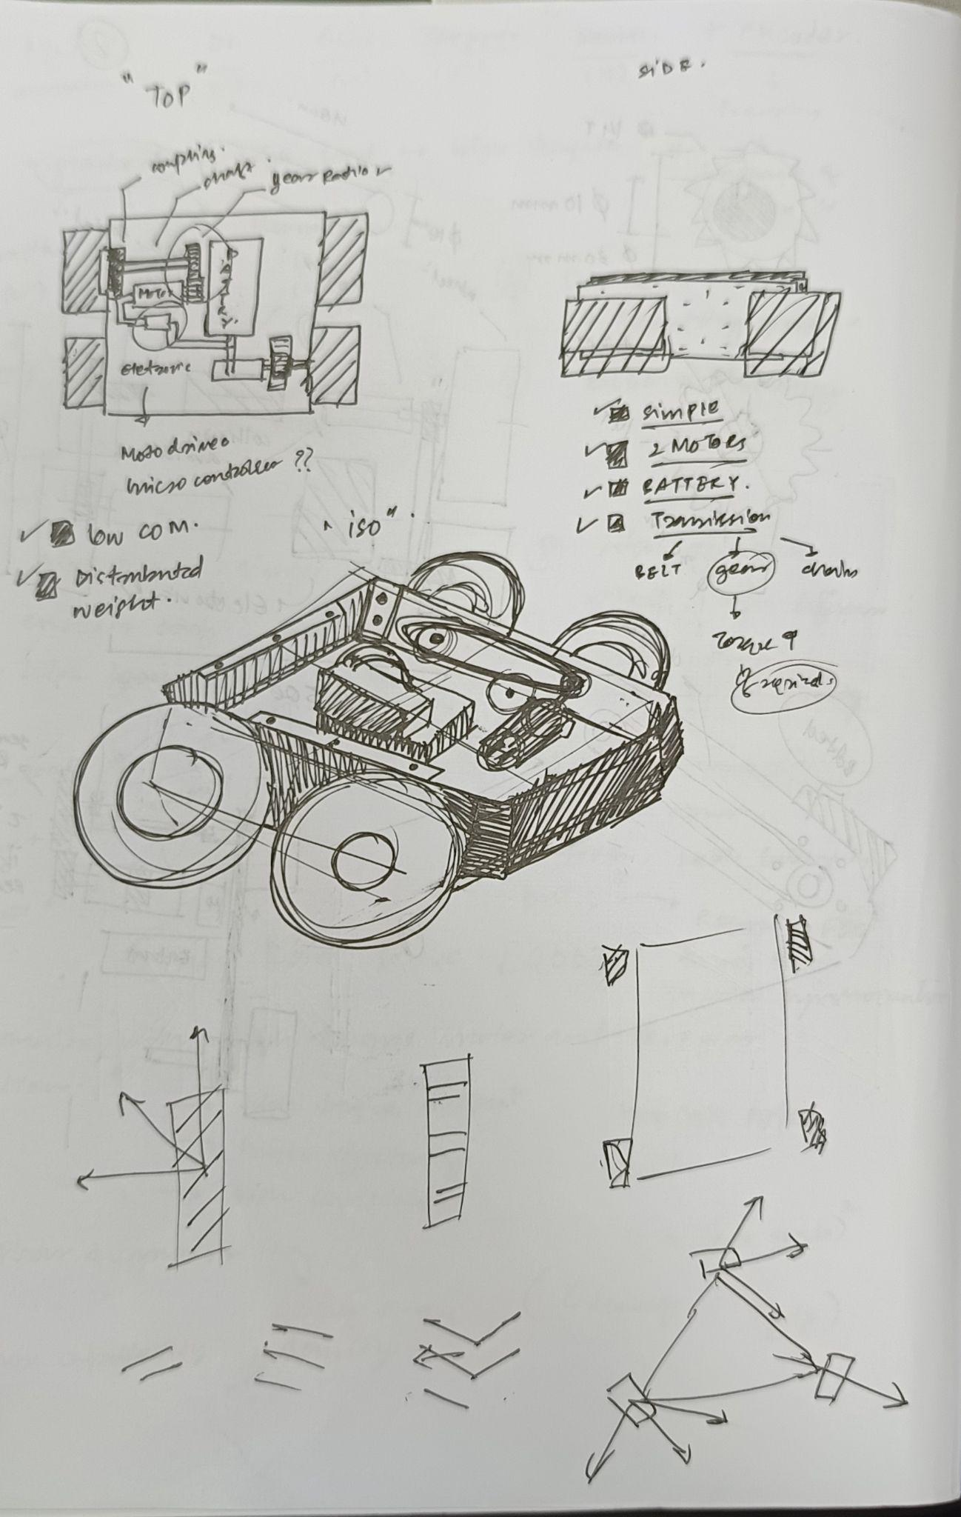
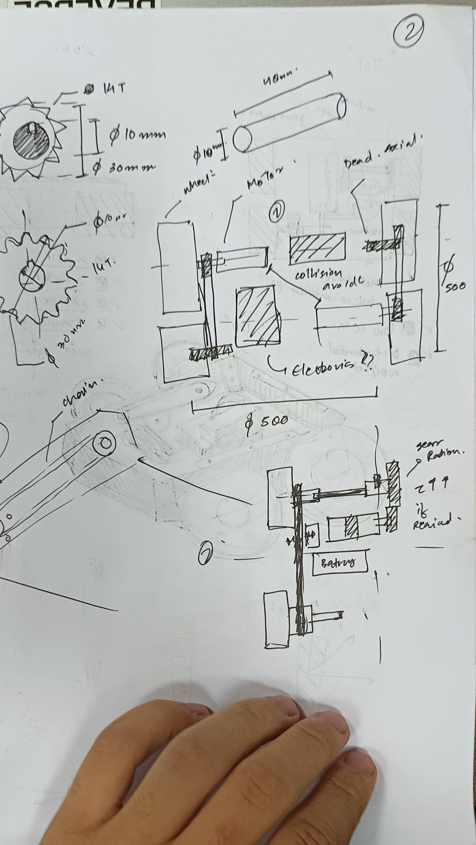
Before beginning the CAD work, the team sketched multiple concepts on paper to communicate ideas effectively and evaluate different drivetrain and chassis arrangements.

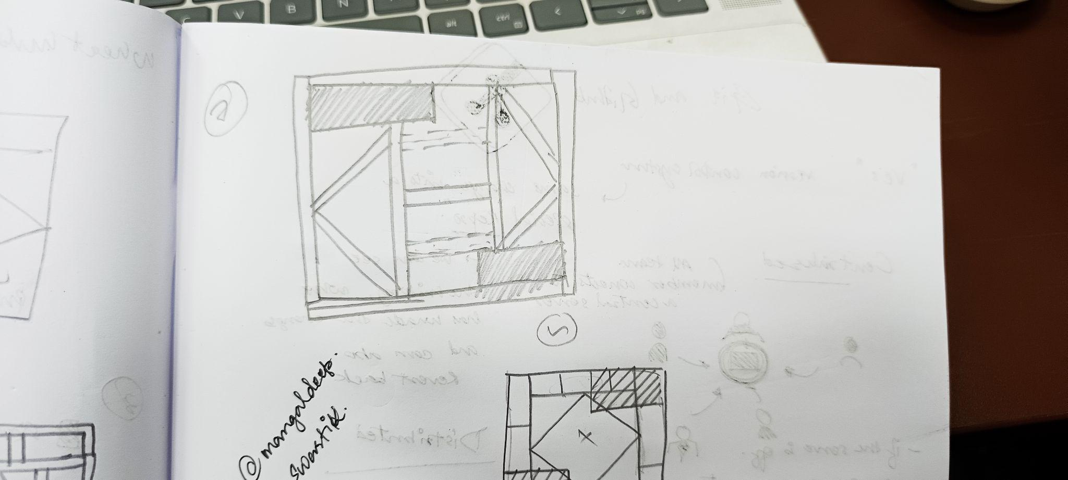
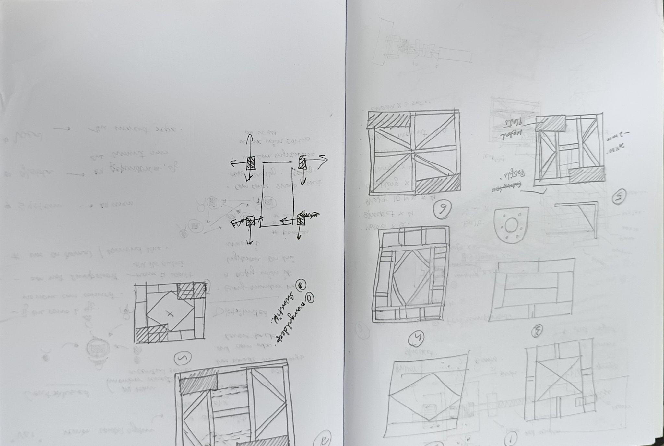

The final objective was to create a compact, rigid, and plug-and-play robotic platform capable of supporting modules such as LiDAR, robotic arms, cameras, and other experimental payloads.

CAD Design:
This stage marked the beginning of the actual development process, where the team started creating CAD models of the provided mechanical components and chassis assemblies. Sushant primarily handled the chassis CAD design, while Krish worked on the drivetrain assembly and Aranis contributed to both design and manufacturability improvements.
The first task involved modelling components such as:
- Dead shaft assemblies
- 775 series motors
- Chain and sprocket system
- Bearings and couplers
One major challenge during this stage was the lack of accurate CAD models available online for several components. In many cases, only technical drawings were available, requiring the team to manually model parts using dimensions from datasheets. Some components did not even have proper drawings available, so physical measurements had to be taken manually using rulers and calipers before recreating the parts in CAD software.
The initial chassis CAD was designed using 20x20 aluminium extrusion dimensions. However, during manufacturing preparation, the team discovered that the actual profiles had outer dimensions of 24x24 mm, while 20x20 mm represented only the inner dimensions. Due to this mismatch, the chassis had to be redesigned to accurately reflect the real extrusion geometry.
Several chassis concepts were explored during the design phase. One design used an “X” truss arrangement, while another followed a diamond-shaped reinforcement structure. Both concepts incorporated diagonally aligned shafts because triangular and diagonal load paths provide significantly better rigidity and load distribution under impact conditions. Using finite element analysis (FEA), the team later determined that a hybrid combination of both designs provided the best structural performance.
The finalized chassis dimensions were approximately:
- 371 mm × 371 mm
The drivetrain configuration included:
- 4 × 775 Series IG Gearbox Motors
- 4 × 2.50-4 Wheels
- #25 Chain and Sprocket Transmission
- 2 × 14T Sprockets
- 2 × Dead Shaft Assemblies
The team also considered adding additional truss members within the frame to improve impact resistance and overall structural rigidity.
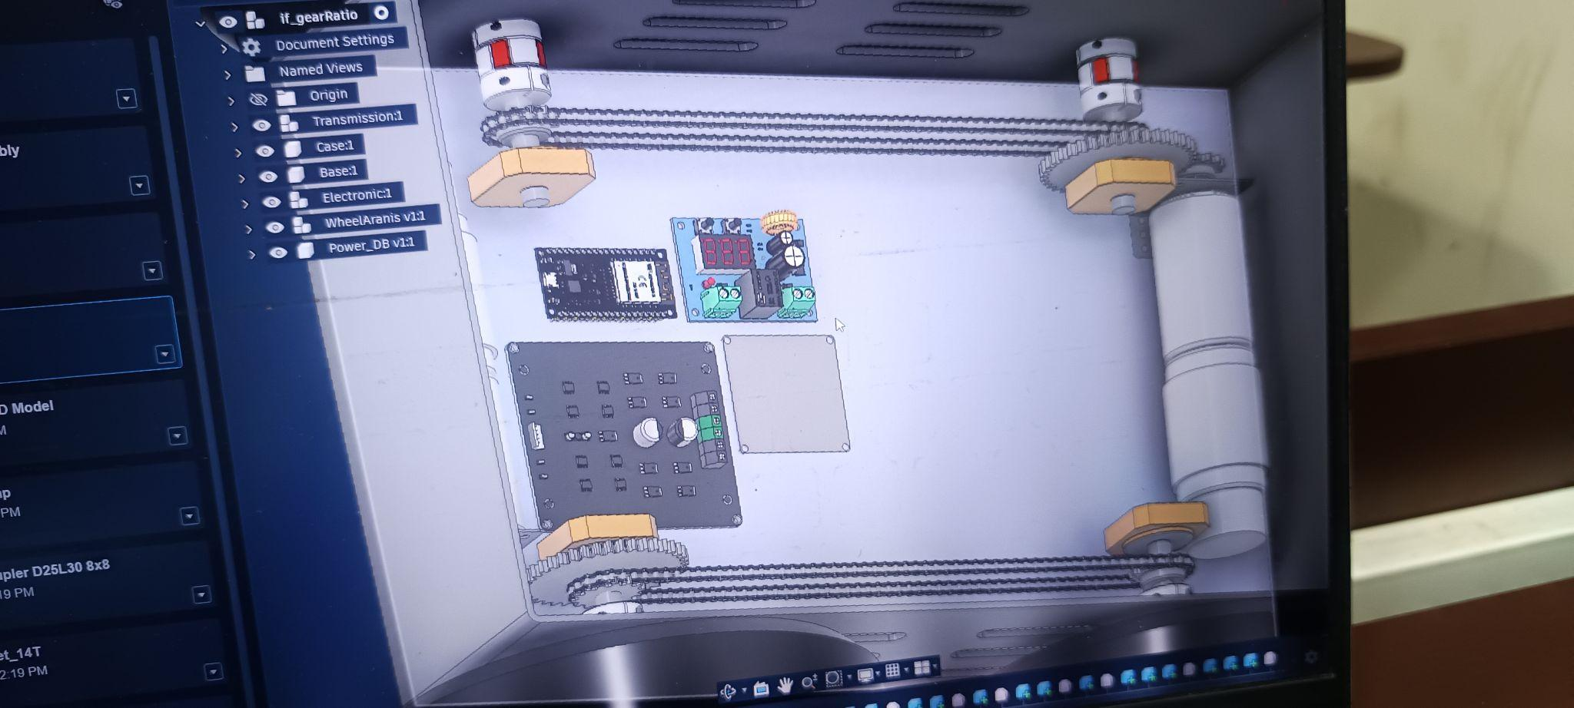
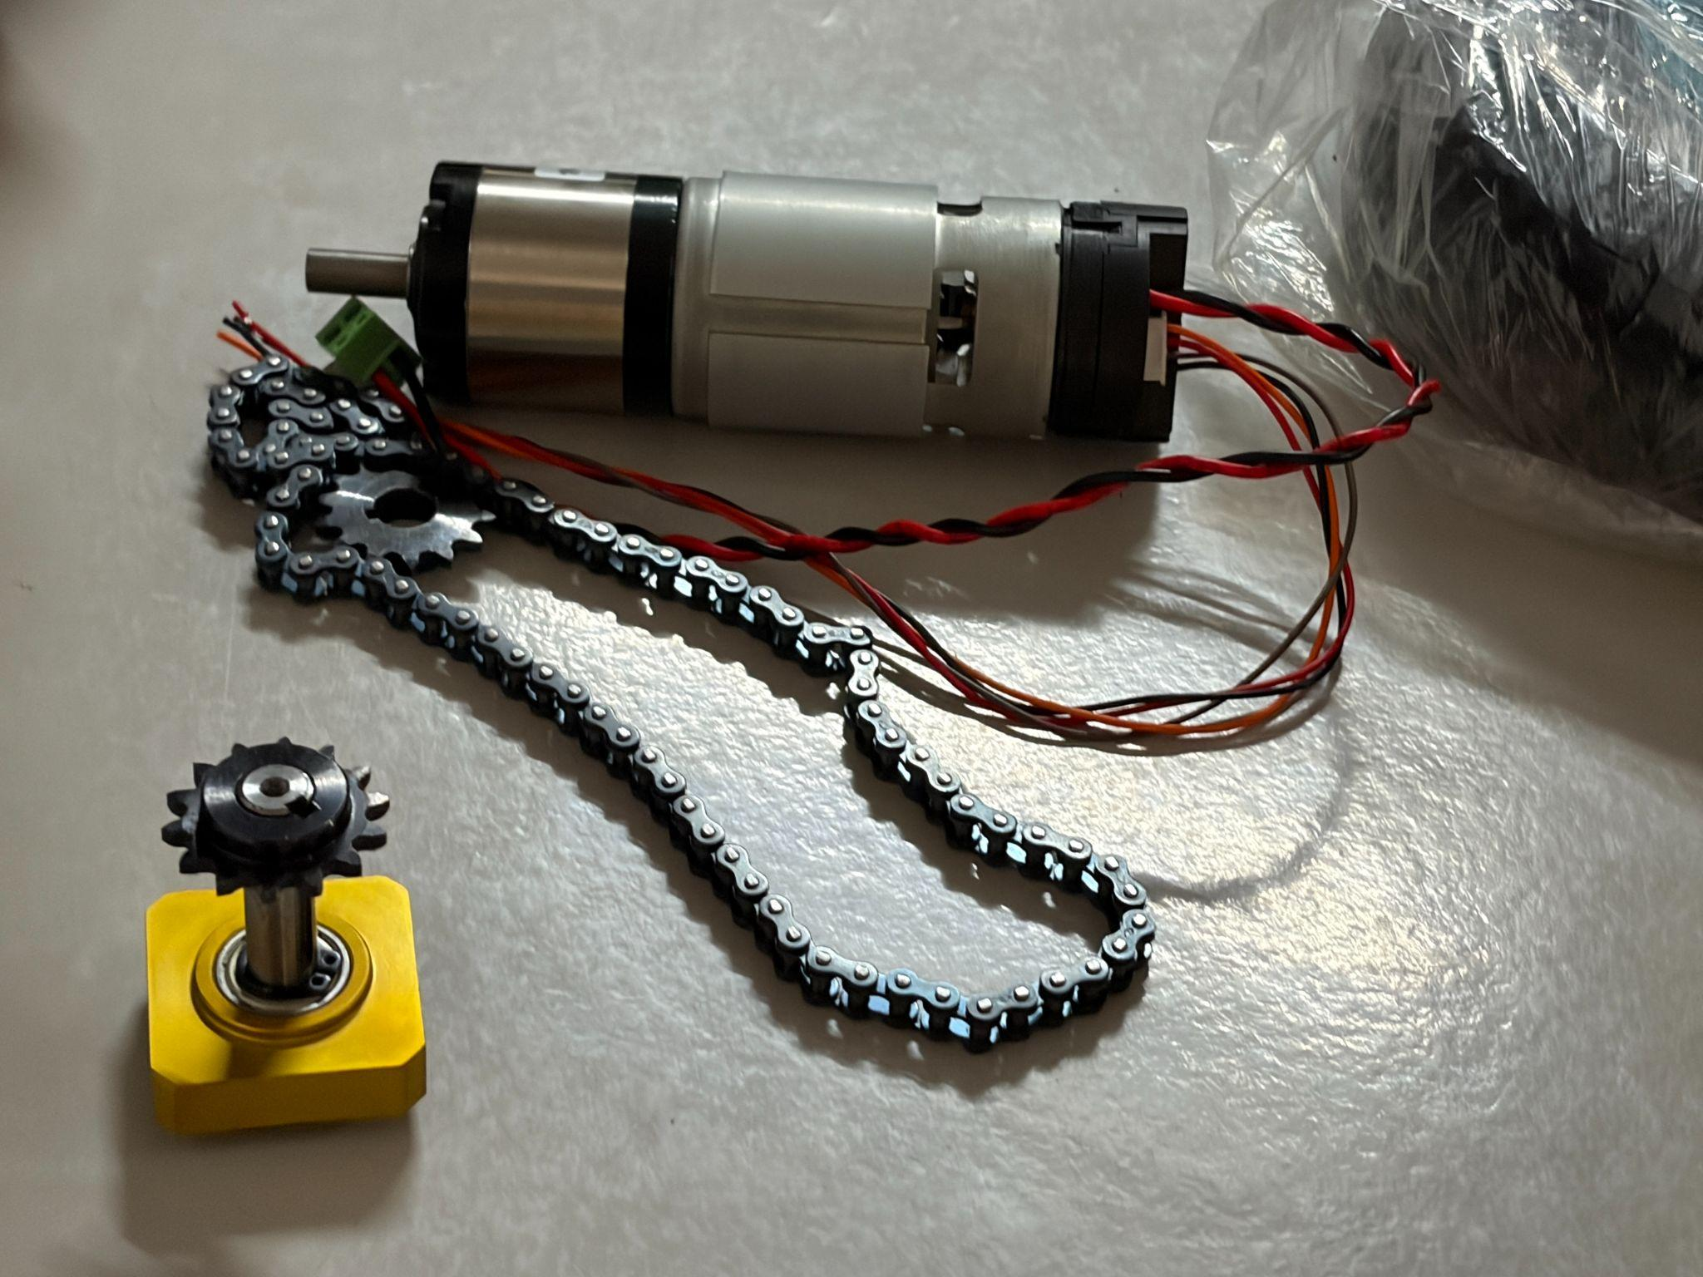

After finalizing the basic chassis structure, another CAD assembly was created containing all major components such as motors, shafts, wheels, and transmission systems. This helped visualize the final robot layout and identify mounting challenges early in the design process.
During this stage, the team realized that mounting motors and dead-shaft assemblies directly onto the chassis would weaken the aluminium profiles due to excessive drilling. To solve this, removable mounting plates were introduced. These plates provided multiple advantages:
- Reduced damage to the structural chassis members
- Easier drilling and assembly
- Improved modularity and maintenance
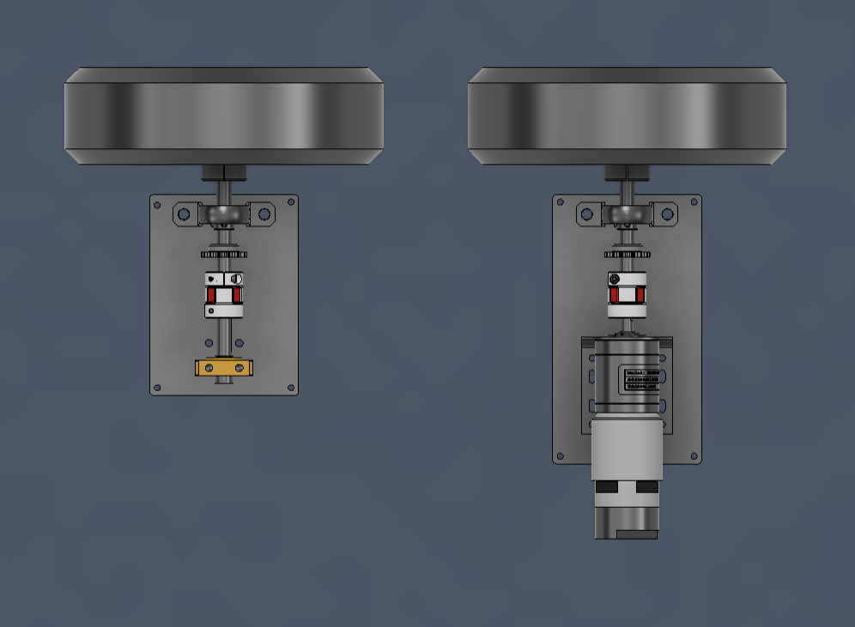
- Flexibility in material selection for non-structural components
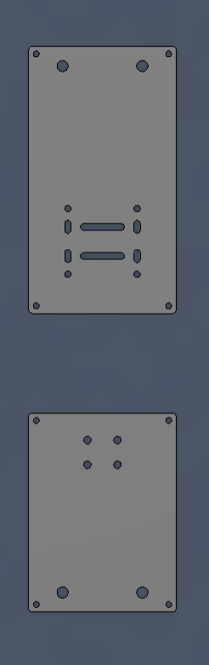
Initially, these mounting plates were planned to be manufactured using mild steel sheets. However, due to the unavailability of laser cutting facilities, the design was modified for additive manufacturing using Nylon Carbon Fiber filament.

To make the motor mounts suitable for 3D printing:
- Plate thickness was increased from 2 mm to 5 mm
- Additional ribs and fillets were added for reinforcement
- Mounting regions were strengthened
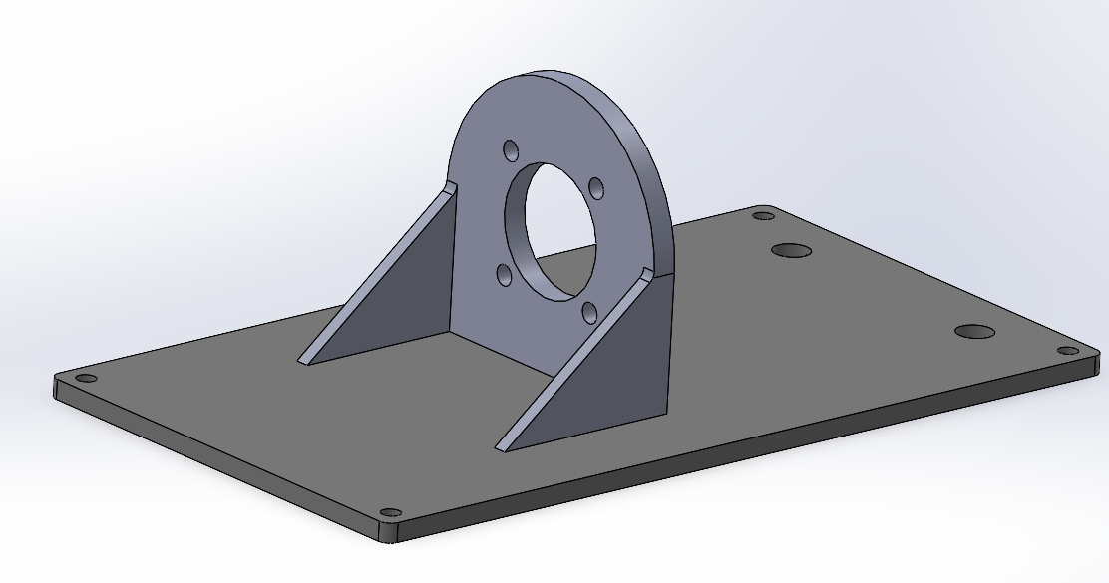
- A tolerance of +0.2 mm was added in CAD for printer inaccuracies and proper fitment
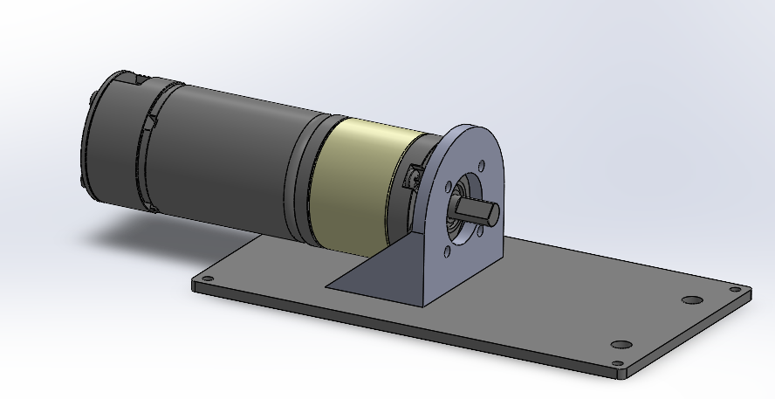

Aranis contributed significantly during this redesign process by improving the manufacturability of the printed parts.
The team used both SolidWorks and Fusion 360 during the CAD development phase based on individual comfort and workflow efficiency. Aranis was more comfortable working in SolidWorks, especially for detailed part modelling and constraint-heavy assemblies. On the other hand, Sushant and Krish primarily used Fusion 360 for designing and iterative development of the chassis and drivetrain components.
Fusion 360 was preferred for most of the main design work because it allowed easier collaboration and seamless file sharing between team members without compatibility issues. It also enabled faster iterations during the ideation and modification stages of the chassis. Aranis also explored Fusion 360 alongside SolidWorks so that he could support the workflow when changes or updates were required, ensuring that modifications could be quickly accessed or downloaded without conversion issues.
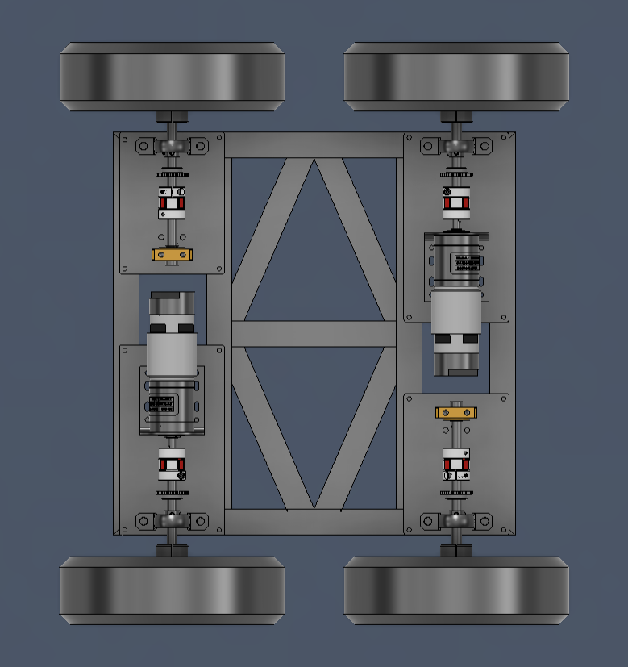
Common CAD operations used throughout the project included:
- Extruded cuts
- Chamfers
- Fillets
- Sweep
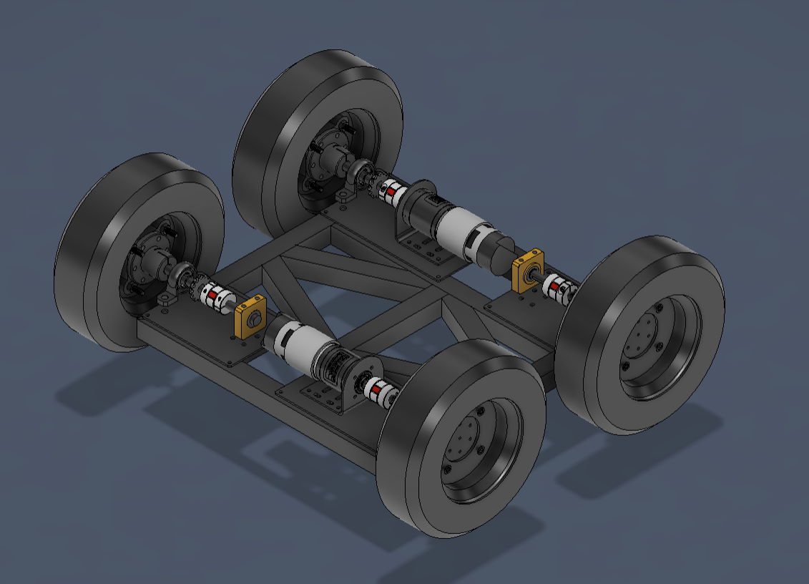
- Assembly constraints
The team used both SolidWorks and Fusion 360 depending on the complexity of the task and prior experience. Fusion 360 allowed faster conceptual development, while SolidWorks provided better control for complex assemblies and mechanical constraints.

Problems Faced During CAD Development
One recurring issue during the design phase was the lack of accurate CAD models for the 775 series motors. Most available online models had incorrect dimensions, especially around the gearbox and encoder sections. To solve this issue, the team imported separate CAD models for the motor and gearbox, while manually modelling the encoder section as a simplified solid body. This approach allowed accurate assembly positioning and simplified the motor mount design process.

FEA Analysis:
Krish was primarily responsible for performing the Finite Element Analysis (FEA) and simulation of the chassis designs. The purpose of this analysis was to evaluate whether the proposed chassis structures could withstand operational loads, vibrations, and impact forces while maintaining sufficient structural rigidity. Additionally, the simulations were used to compare different chassis concepts proposed by Aranis and Sushant before finalizing the design.
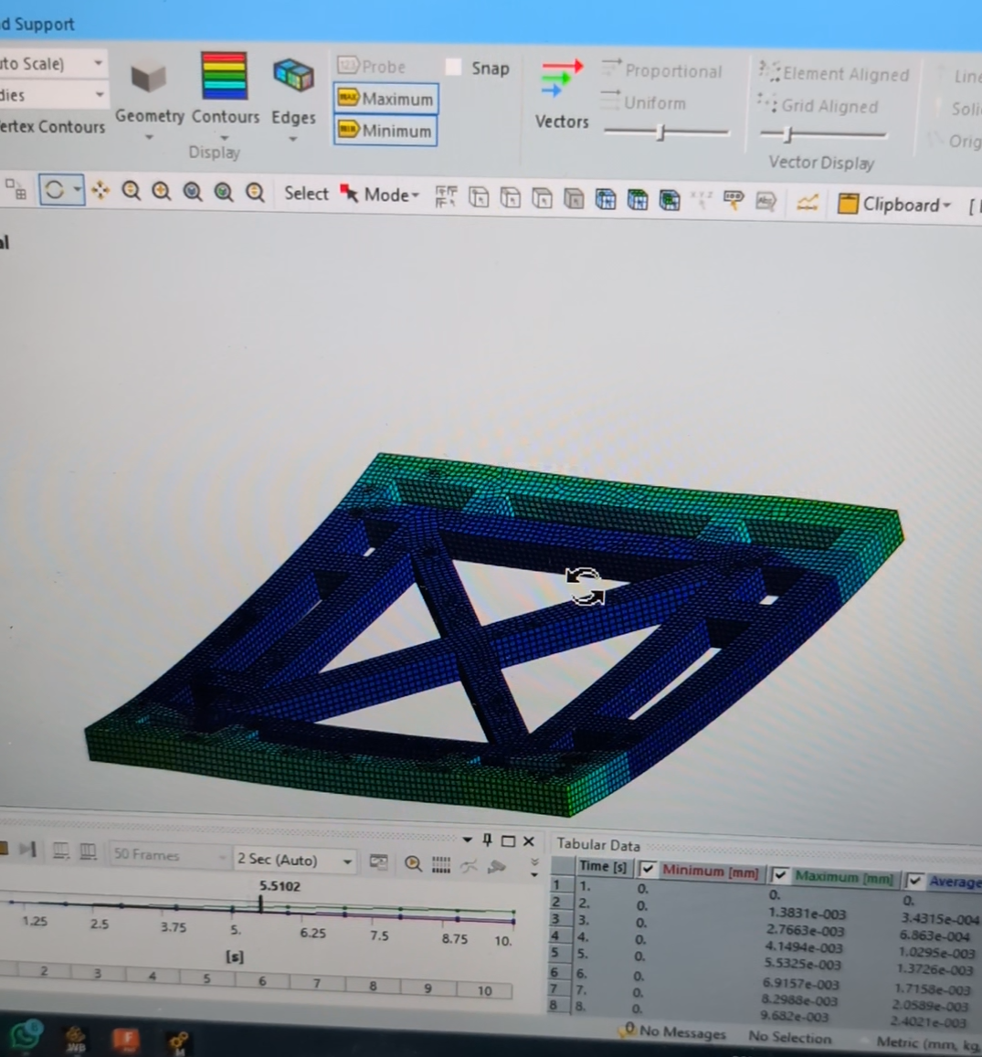
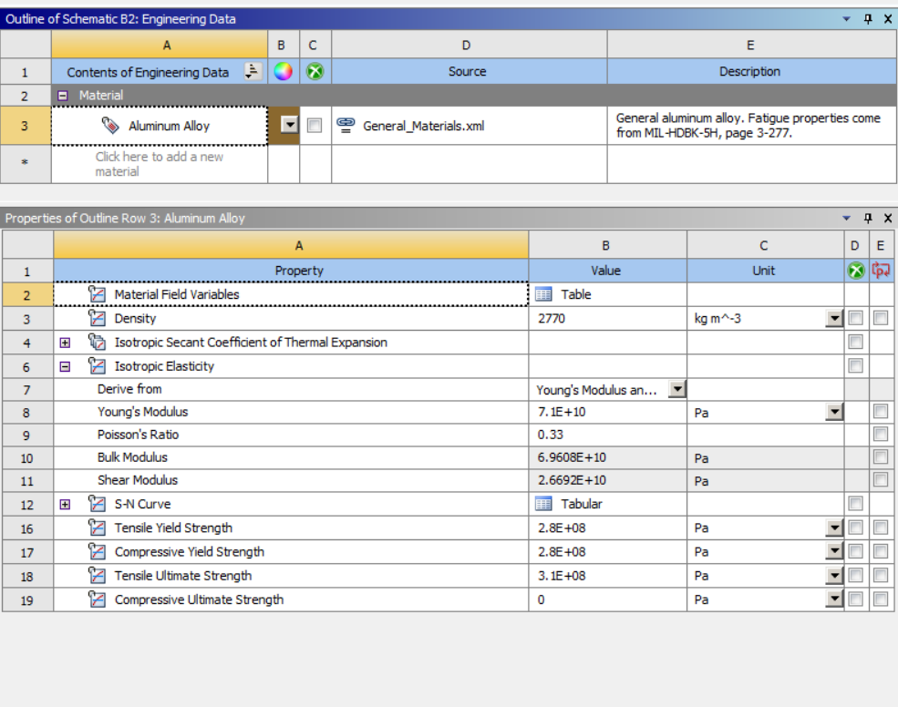
Before running the simulation, the CAD model was simplified to reduce computational complexity without affecting result accuracy. Small or non-critical features were removed, and hollow aluminium extrusion profiles were approximated as solid members to make meshing more efficient. The individually modelled chassis links were also merged into a single rigid assembly to ensure proper load transfer during simulation.

Material properties for aluminium were assigned using the software’s material library. The key properties defined included:

Young’s Modulus
- Poisson’s Ratio
- Density
- Yield Strength
The standard FEA workflow followed during the analysis included:
- Preparing and simplifying the CAD model
- Assigning material properties
- Defining boundary conditions and constraints
- Applying external loads and forces
- Generating mesh elements
- Running the simulation
- Evaluating stress and deformation results
For the chassis study, fixed constraints were applied at the central mounting region of the frame to simulate realistic support conditions, while loads were applied at the corners and motor mounting locations to replicate actual operating conditions. Additional lateral impact loads were also considered to simulate rough terrain usage and possible collisions during operation.
Different chassis configurations (including X-truss and diamond-style layouts) were evaluated based on:
- Total deformation
- Stress distribution
- Structural rigidity under load
The simulation results helped identify regions with stress concentration and excessive deformation. Based on these observations, design improvements such as better load distribution, optimized support placement, and increased truss reinforcement were suggested to improve overall stiffness and durability.
Overall, the FEA results played a crucial role in finalizing the chassis design before manufacturing, significantly reducing the risk of structural failure and minimizing trial-and-error during fabrication.

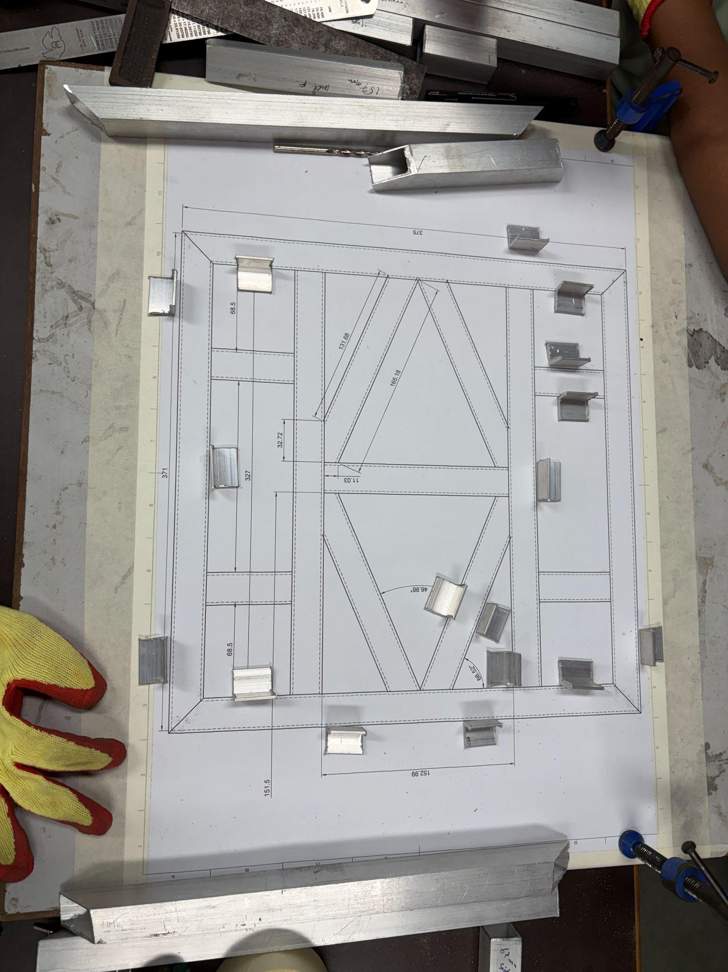
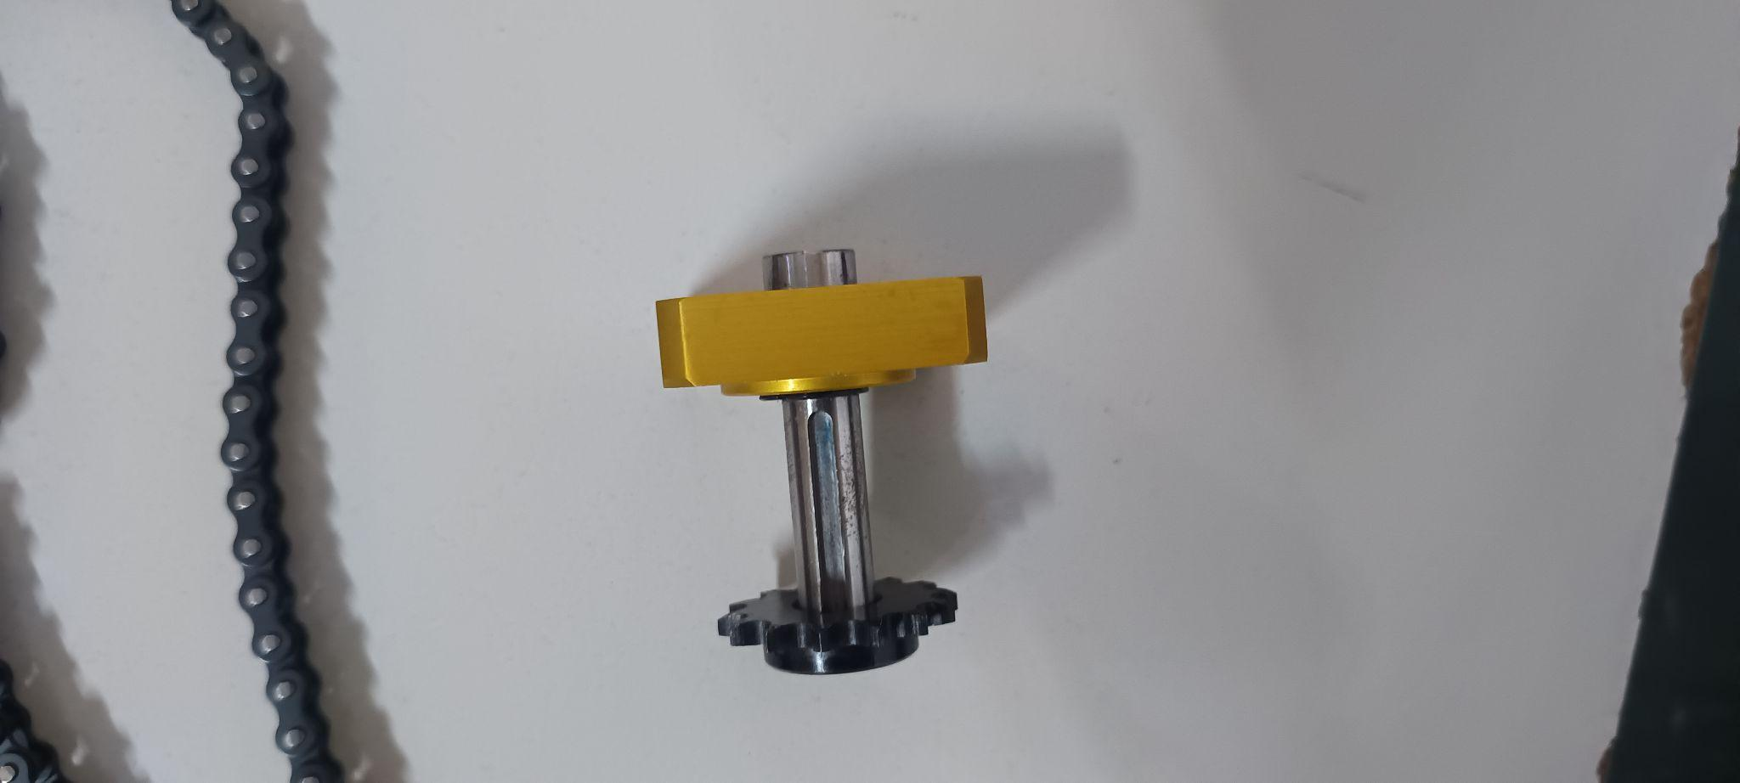
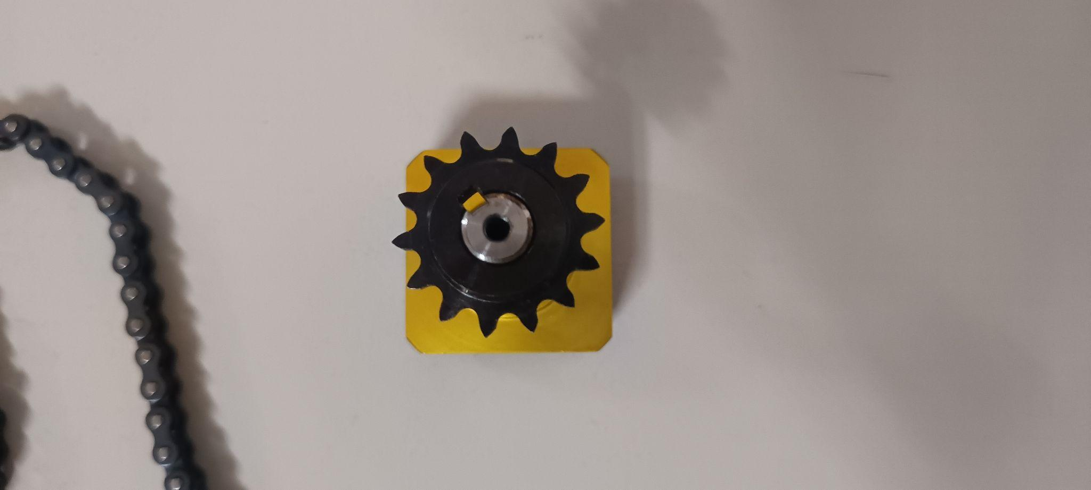
Manufacturing
Our manufacturing process began after finalizing the CAD design and FEA validation. The team first discussed the manufacturing approach with the mentor and procured all required materials and tools.
The base material used for fabrication was square aluminium extrusion profiles with an outer dimension of 24 mm × 24 mm and an inner hollow section of 20 mm × 20 mm. These profiles formed the main structural frame of the chassis.
Due to miscommunication however, the team members assumed the outer dimensions to be 20 mm x 20 mm. Which caused them an unnecessary headache in trying to reduce the dimensions of the already cut parts. A small miscommunication converted into a very big rookie mistake.
To fabricate the chassis components, aluminium profiles were cut using an angle grinder. This process required careful handling due to safety risks such as:
- Metal fragment ejection
- Sharp edge exposure
- Risk of hand injuries during cutting
Proper safety precautions and controlled handling were necessary to mitigate these risks such as using safety glasses and gloves.

Tolerances and Fitment Issues
A critical aspect of manufacturing was understanding and applying tolerances. In real-world fabrication, achieving exact CAD dimensions is not feasible, especially with manual cutting methods. To account for this, a 1 mm tolerance gap was initially maintained between cuts.
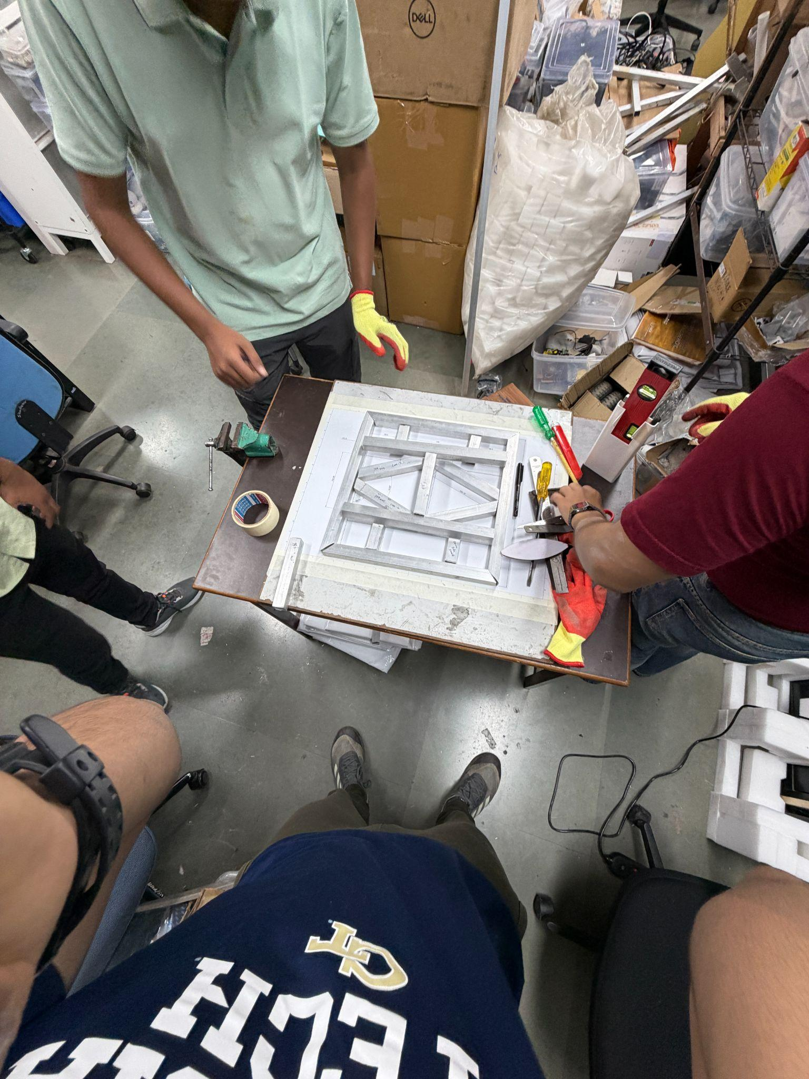
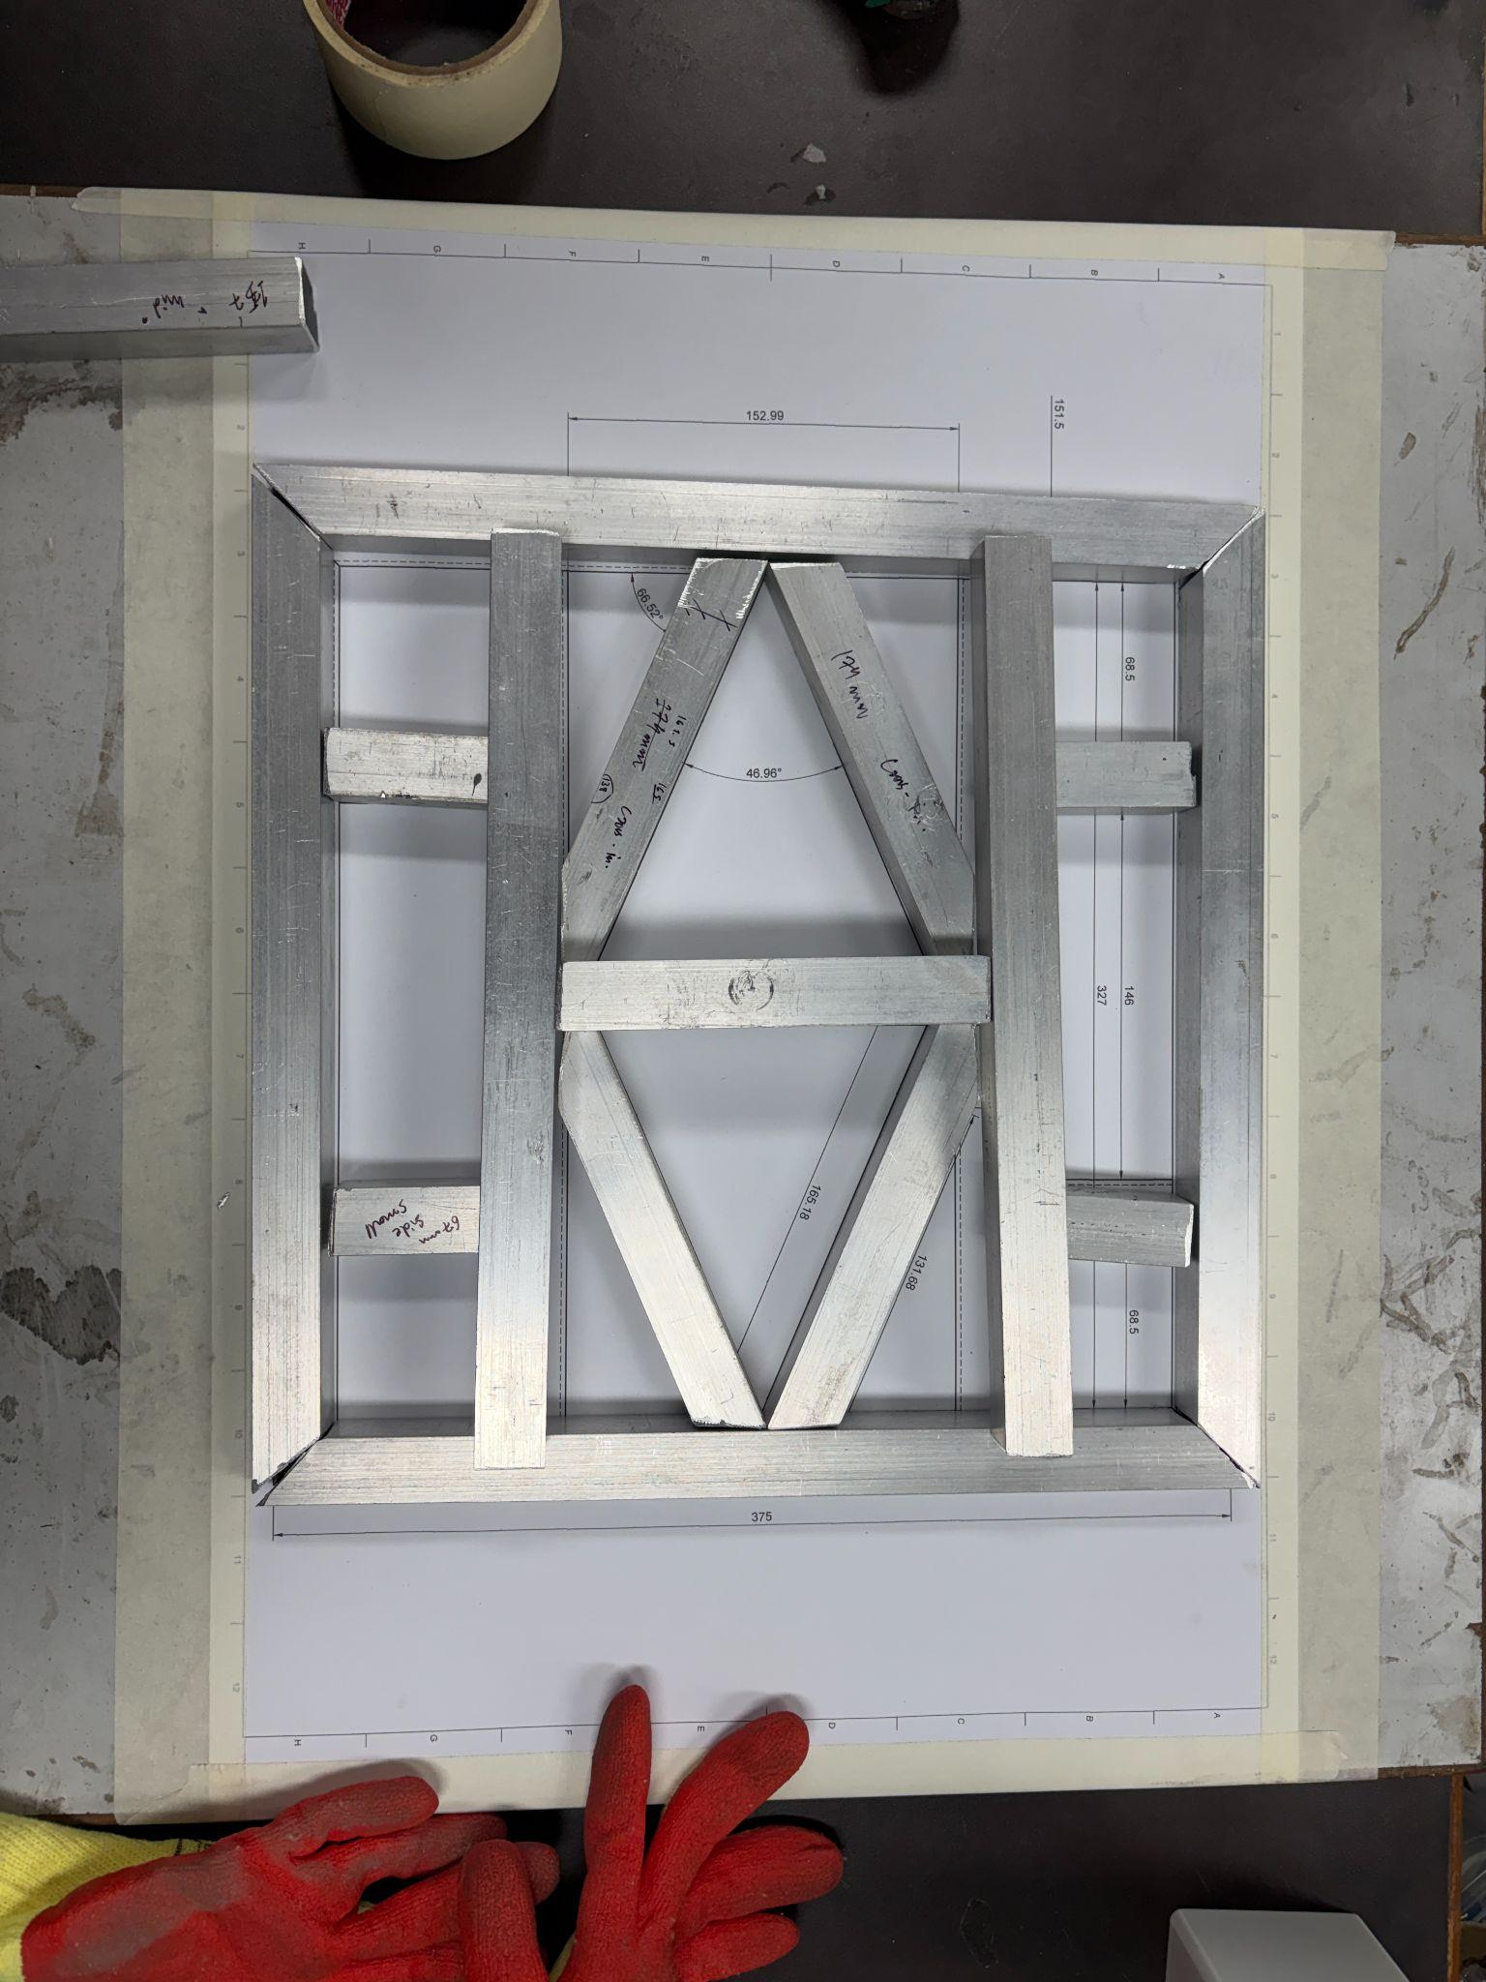
However, this tolerance proved insufficient, leading to dimensional mismatches. As a result, several aluminium pieces were slightly oversized and did not fit together as intended. The team had to perform additional trimming operations and repeatedly adjust component lengths.

Extensive deburring was also required after cutting. This step was essential to ensure proper fitment, safety during handling, and clean assembly of chassis joints.

Manufacturing Process (Assembly Stage)
After CAD finalization and analysis, the team developed the manufacturing plan and arranged the required tools and materials.

Materials and Tools Used
- Aluminium extrusion profiles
- Grinding wheel
- L-shaped mounting brackets
- Wooden base plate
- 1:1 scale draft print
- M4 bolts and fasteners
- Flat file
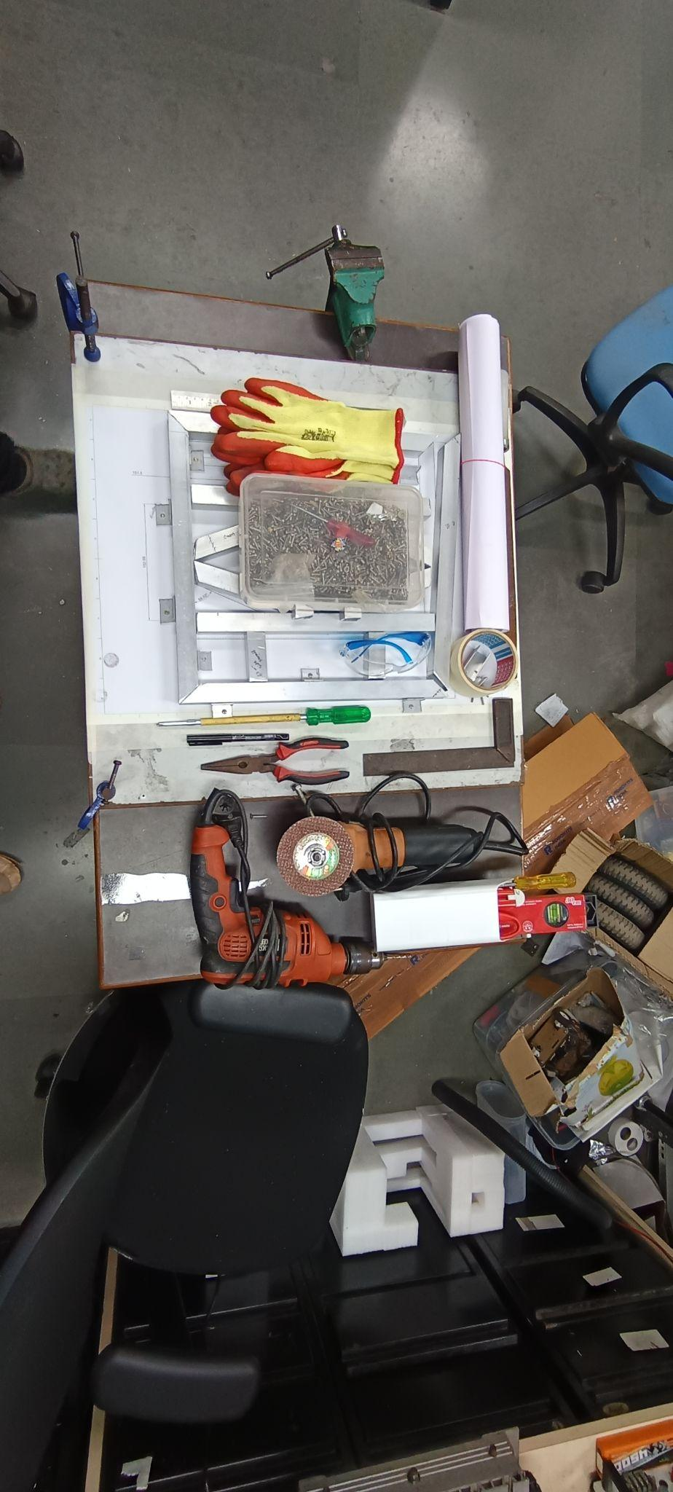
- Marker
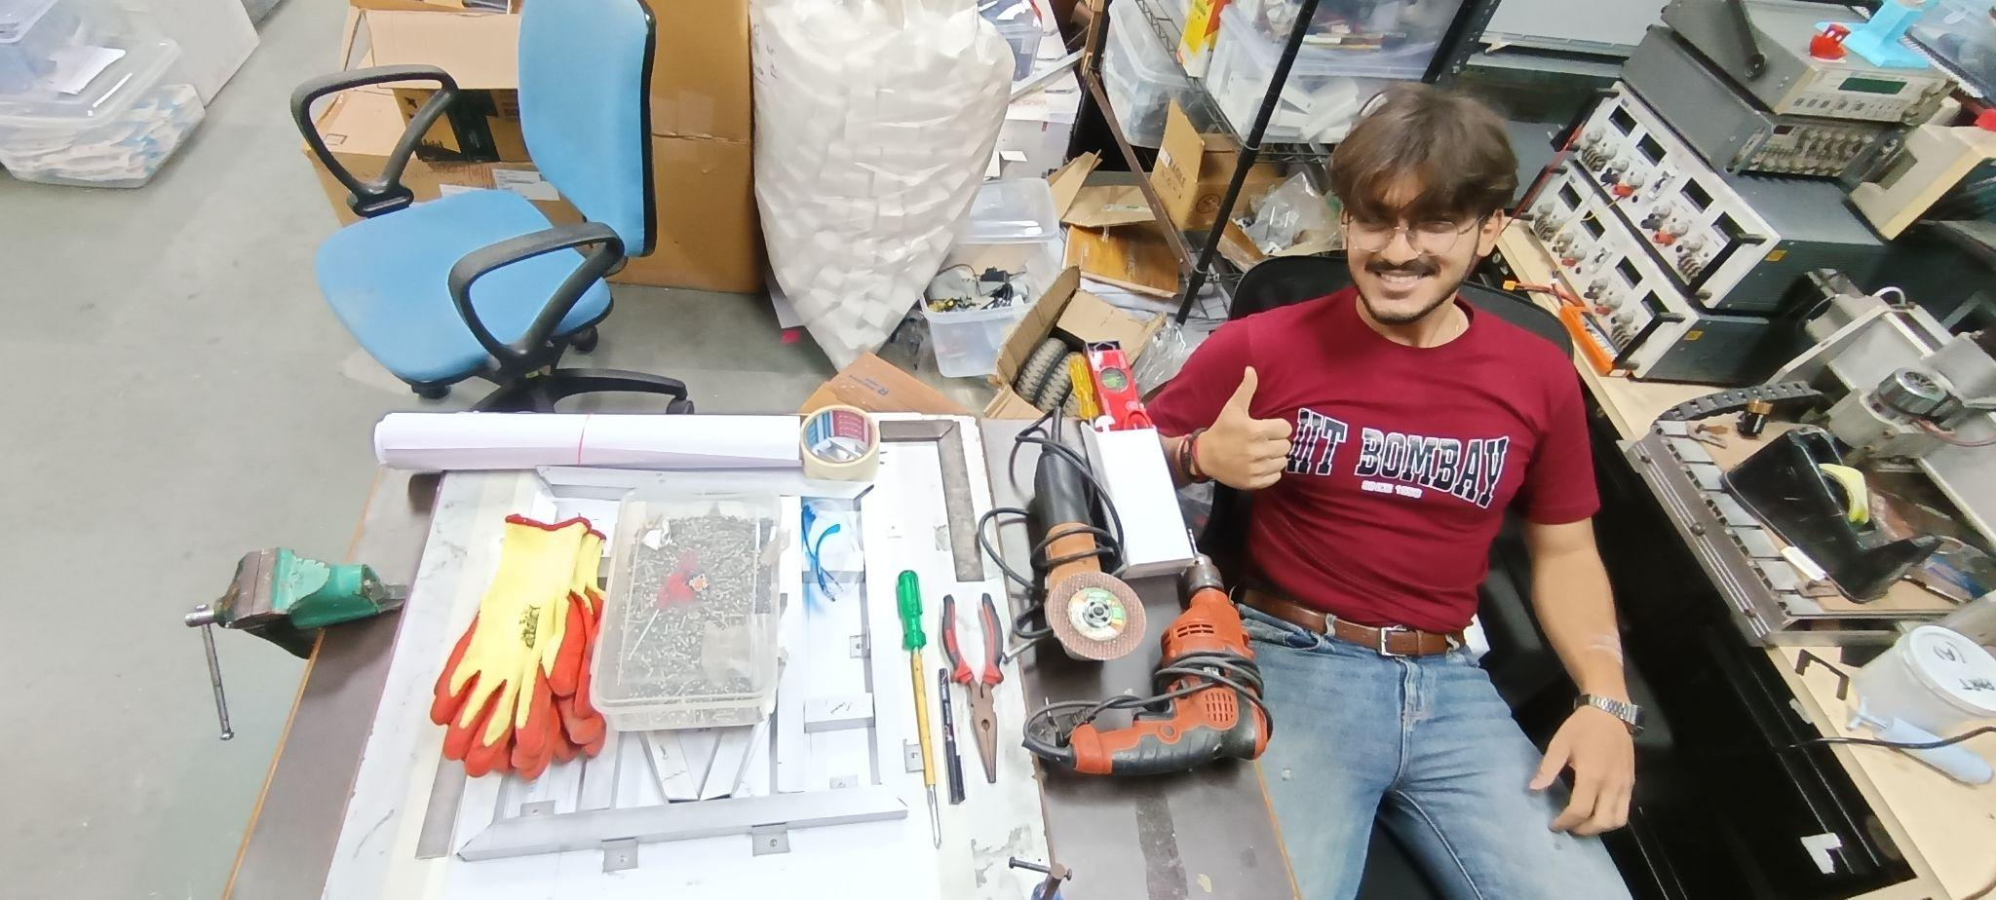
- Drill machine

The first step involved cutting aluminium profiles as per CAD dimensions and arranging them on a 1:1 printed draft placed over a wooden base. This helped in visual alignment before final assembly.
During assembly, the team encountered multiple practical issues. The L-brackets used for joining were manually cut, resulting in inconsistent lengths, which caused alignment errors. Additionally, the wooden base mounting system was not included in the original CAD model, leading to unexpected constraints during assembly.
To stabilize the chassis during fabrication, the structure was initially constrained in the X and Y directions while allowing slight movement in the Z-axis. To improve this setup, Aranis designed a custom U-clamp, which was later 3D printed to verify fitment and dimensional accuracy.

Welding and Structural Challenges
A major challenge during manufacturing was planning for welding and structural stability. Since the chassis needed to be flipped during welding, the fixture had to remain both rigid and removable.
The team initially explored multiple solutions:
- A 3 mm acrylic plates bolted to the frame
- Multiple custom-cut fixture plates
However, both options were rejected due to complexity, time consumption, and poor practicality.
Another approach involved a sandwich-style fixture using wooden plates above and below the chassis. This also failed because it could not ensure uniform load distribution across the frame, leading to potential distortion.
Finally, a more effective solution was brainstormed. We planned on using additional aluminium extrusion profiles as temporary reinforcement during welding. The mounting of these profiles would have been done as a combination of T-nuts inserted into the profile and then pulled down by bolts to ensure proper clamping. This was combined with using clamps at the extreme corners. This approach provided:
- Better rigidity during fabrication
- More uniform load distribution
- Reduced risk of frame warping
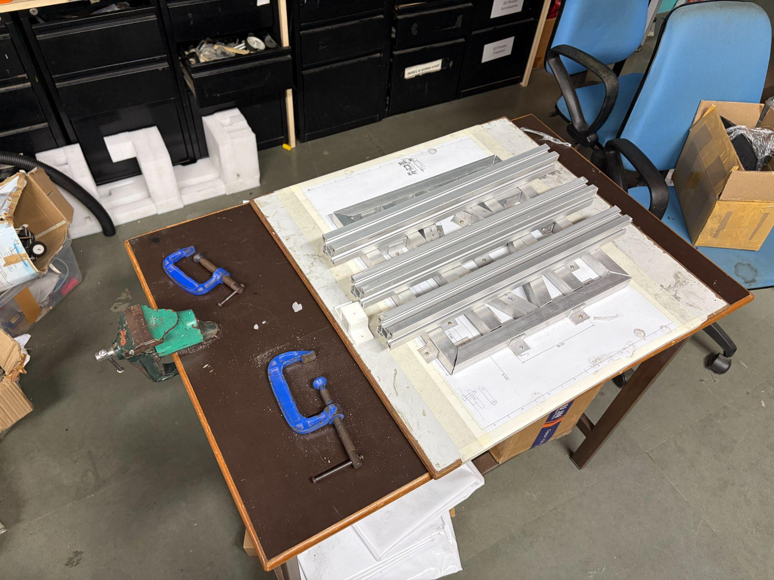
The team adopted this solution for the final manufacturing setup.

Problems Faced and How We Addressed Them

1. Inaccurate Cutting and Tolerances
Problem: Manual cutting using angle grinders led to dimensional inaccuracies, causing parts not to fit properly.
Solution:
- Introduced controlled re-measurement before each cut
- Performed iterative trimming instead of single-step cutting
- Increased practical tolerance margins beyond initial 1 mm assumption
- Used 1:1 printed layout for alignment before final cuts

2. Excess Burr Formation After Cutting
Problem: Aluminium cutting left sharp edges and burrs, making assembly difficult and unsafe.
Solution:
- Introduced mandatory deburring after every cut
- Used flat files and grinding tools for edge finishing
- Ensured smooth mating surfaces before assembly

3. Misalignment Due to Manual L-Brackets
Problem: Manually cut L-brackets had inconsistent lengths, leading to misalignment in chassis assembly.
Solution:
- Measured brackets before installation
- Reworked or replaced inconsistent pieces
- Planned future designs with CAD-integrated bracket constraints

4. Missing Mounting Considerations in CAD
Problem: Wooden base and fixture constraints were not included in the original CAD model.
Solution:
- Updated assembly approach during manufacturing stage
- Introduced custom U-clamp design for better constraint control
- Planned future CAD models with full fixture integration

5. Welding Fixture Stability Issues
Problem: Required flipping the chassis during welding while maintaining structural stability.
Solution:
- Rejected acrylic and wooden sandwich fixture due to poor load distribution
- Adopted aluminium extrusion-based reinforcement frame as advised by mentor
- Ensured uniform force distribution during welding operations

Team Contributions
- Krish: Cutting most of the aluminium profiles (this in itself was a very hefty task)
- Aranis: Filing, finishing, and surface preparation, component CAD design and chassis CAD design
- Sushant: Drilling operations, bracket mounting, component CAD design and chassis CAD design
- Entire team: Assisted collectively in final chassis alignment and assembly fits within our chassis.

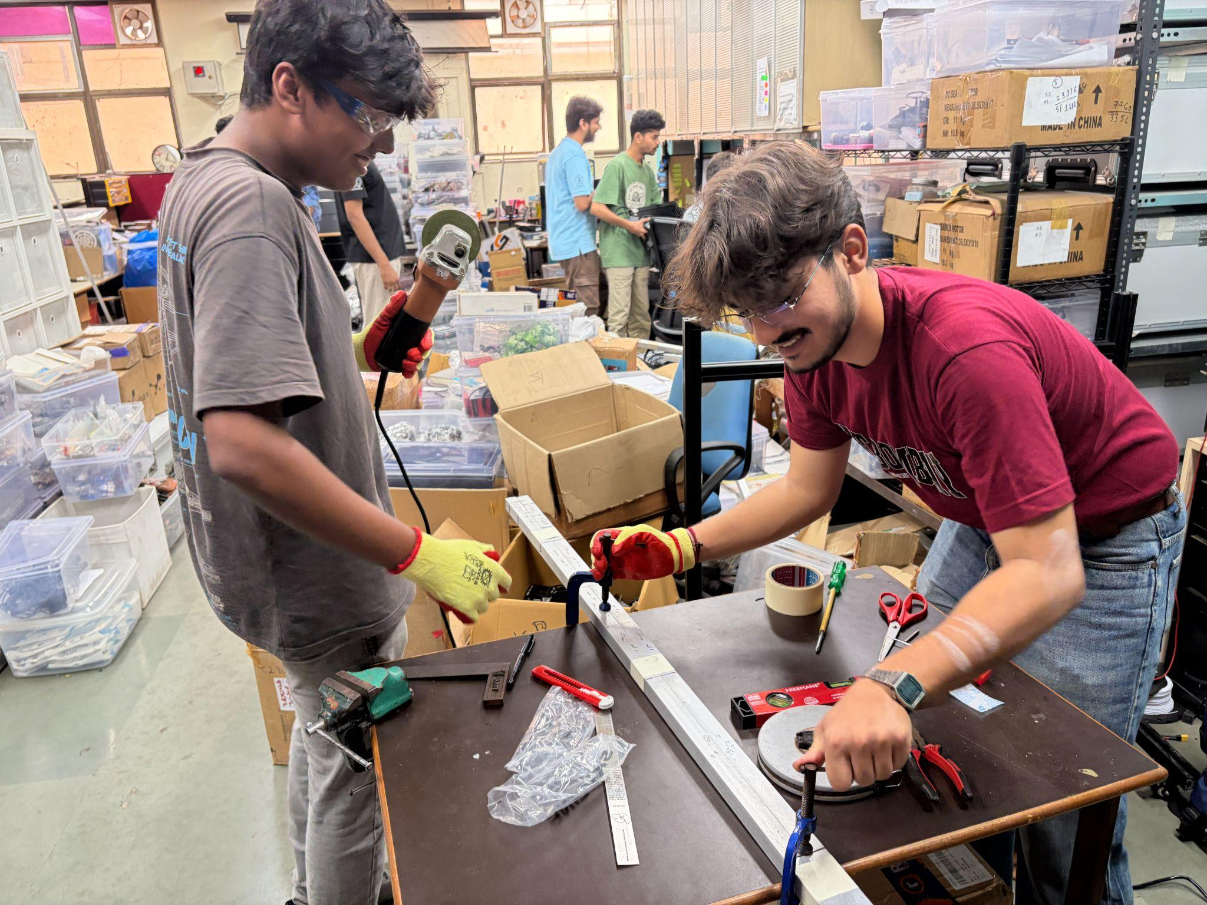
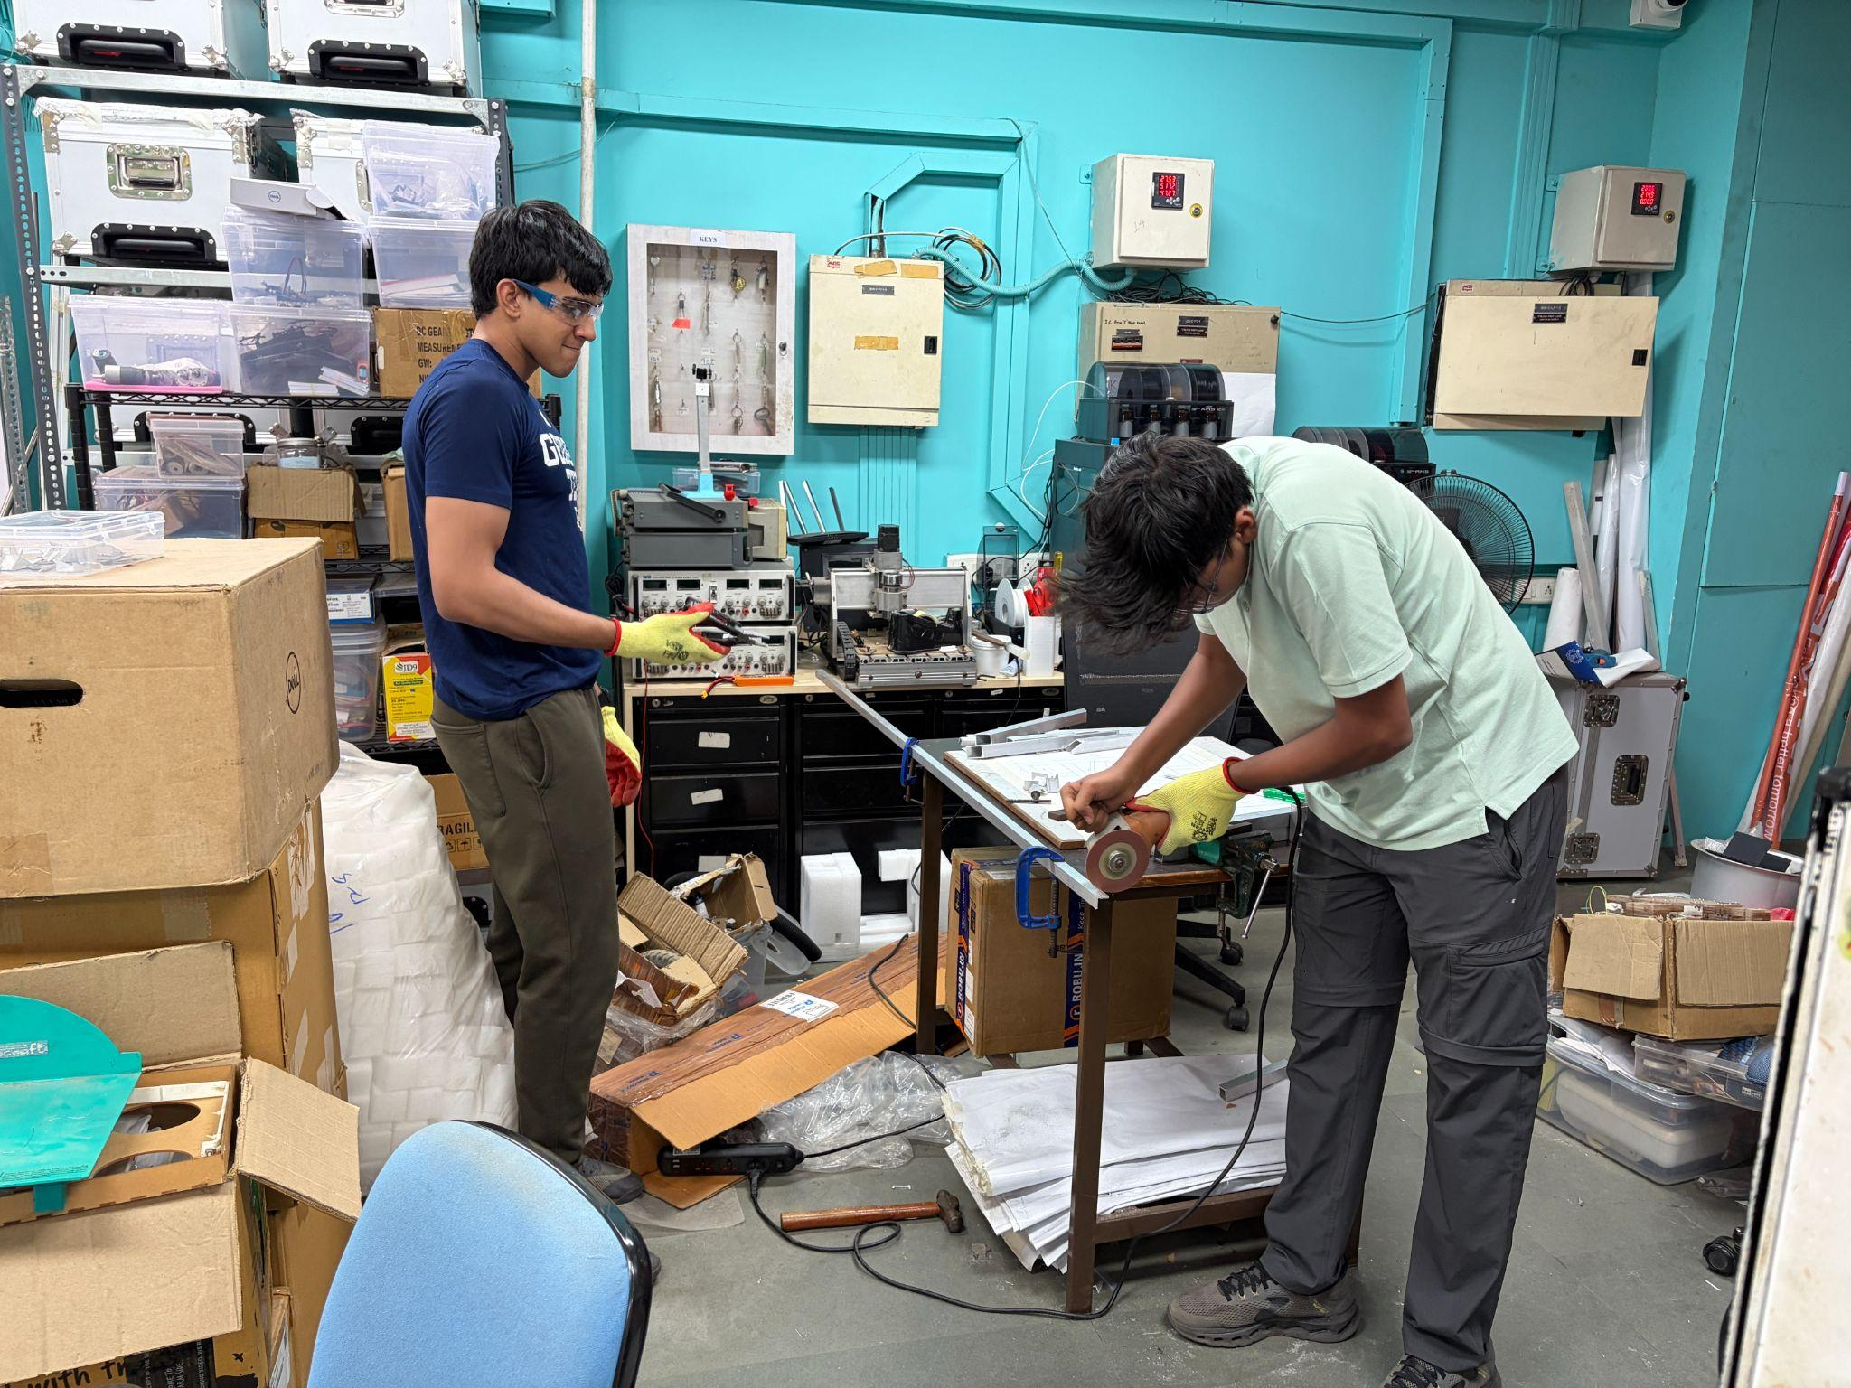

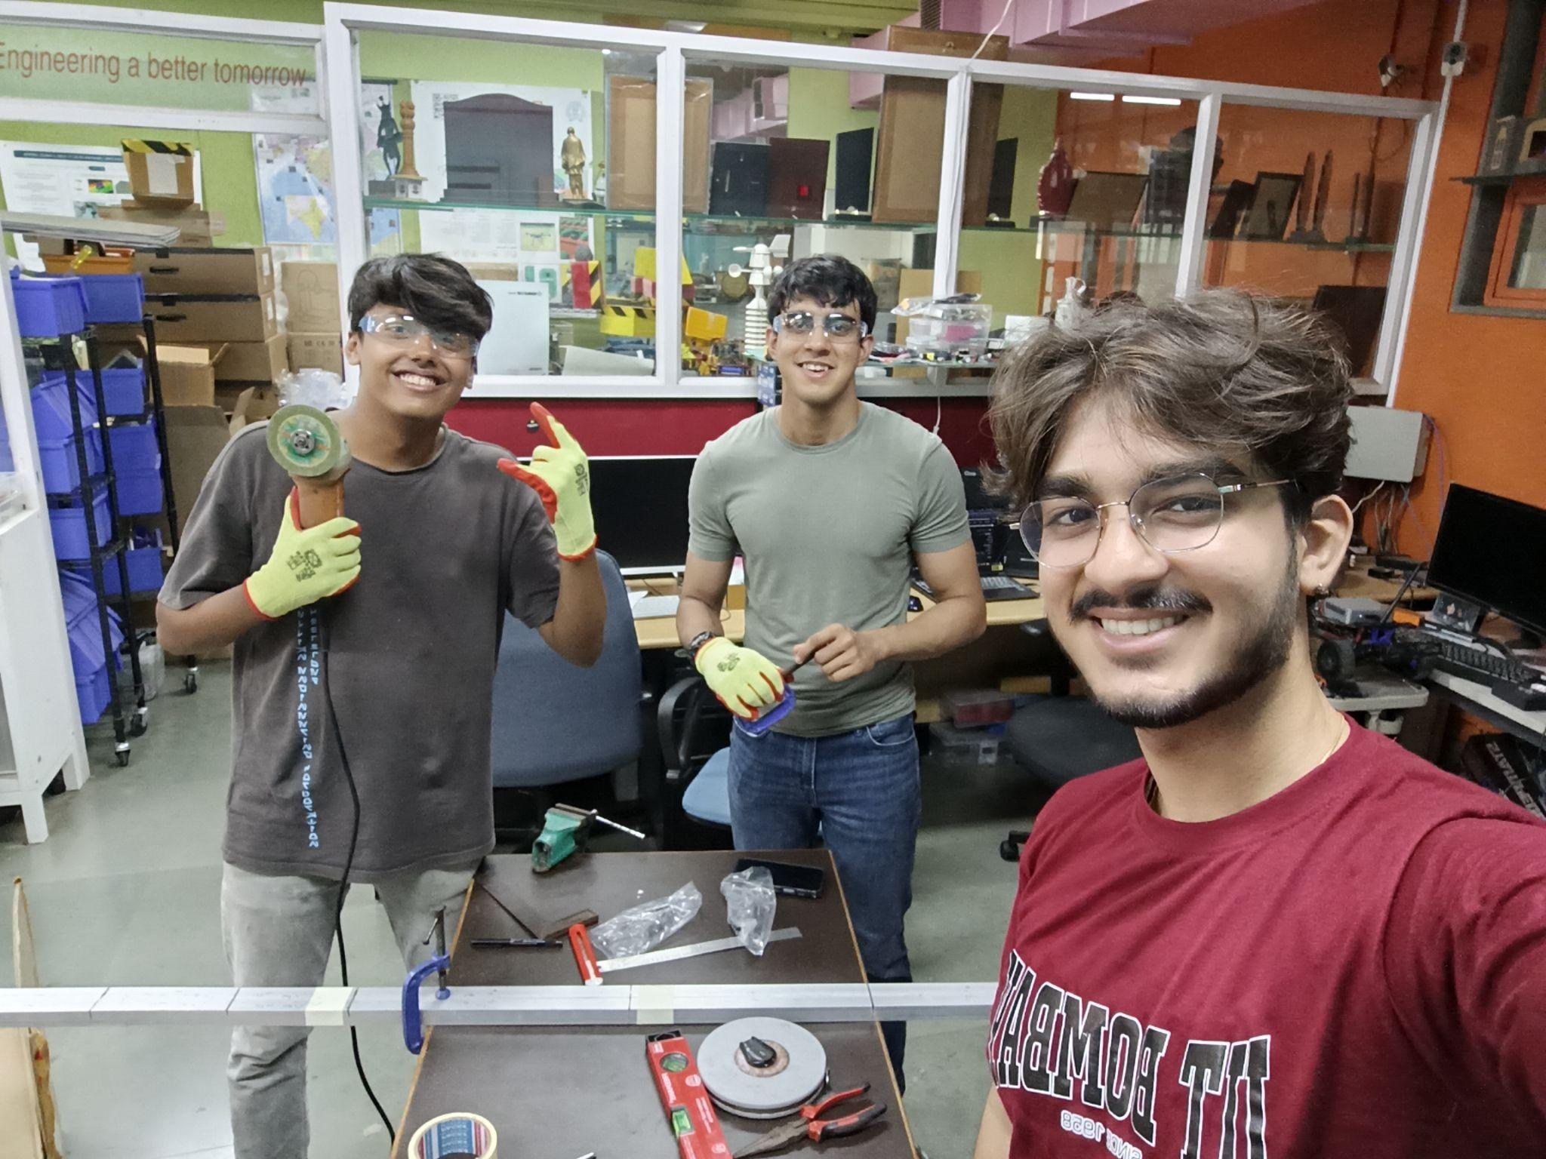

Goals for Upcoming Weeks
Apart from the mechanical subsystem, the project will now extend into electronics and software integration. The next phase of development will include:
- Electronics integration
- Motor control system development
- Software development
- Autonomous system integration
Since all team members come from a mechanical background, the mentor, Siddharth, will be providing structured learning resources to help the team gradually build competency in electronics and software systems required for the robot.

Team Learning Focus and Roles
During the discussion on future direction, each team member identified their area of interest for the upcoming development phase:
- Krish expressed interest in contributing to software development, particularly in ROS (Robot Operating System) and its integration with the robot platform.
- Sushant plans to first gain hands-on experience in embedded systems and microcontroller-level programming, and later transition into learning ROS for higher-level robot control.
- Aranis chose electronics as his primary area of focus, as he is currently less comfortable with software and prefers working on circuit-level design, wiring, and hardware integration.

Future Vision
The long-term goal of the project is to develop a robust, modular robotic platform capable of supporting a wide range of industrial and research applications. The system is intended to be adaptable for different payloads and use cases, including robotic arms, sensors, vision systems, and autonomous navigation modules.

The mentor will share relevant resources for all three domains, and the team will begin the next phase of development in the coming week with a stronger focus on electronics and software integration.

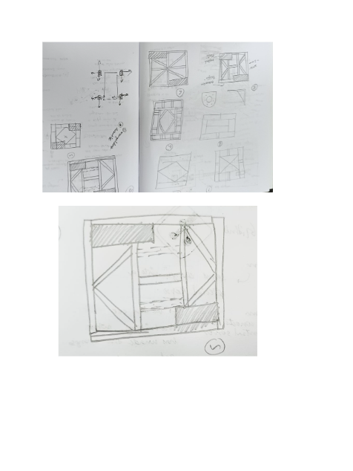
Photo Gallery

